***CS - Archit***

***Week 1 – Von Neumann Architecture***

**1) Who is John Von Neumann?**

- John von Neumann. John von Neumann, original name János Neumann, (born December 28, 1903, Budapest, Hungary—died February 8, 1957, Washington, D.C., U.S.), Hungarian-born American mathematician. As an adult, he appended von to his surname; the hereditary title had been granted his father in 1913.

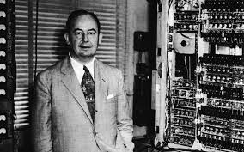

**2) What are the main components of a CPU?**

**Explain them.**

- The two typical components of a CPU include the following:

The arithmetic logic unit (ALU), which performs arithmetic and logical operations.

The control unit (CU), which extracts instructions from memory and decodes and executes them, calling on the ALU when necessary.

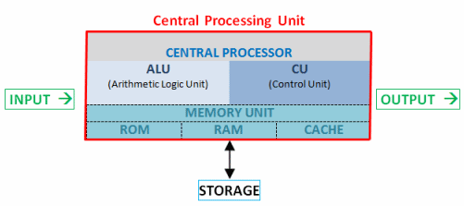

**3) What is the Von Neumann architecture?**

- A von Neumann architecture machine, designed by physicist and mathematician John von Neumann (1903–1957) is a theoretical design for a stored program **computer** that serves as the basis for almost all modern **computers**.

